07_Discover_Comparison Template - 1 Dimension (Vlookup)
Report Views
Standard View
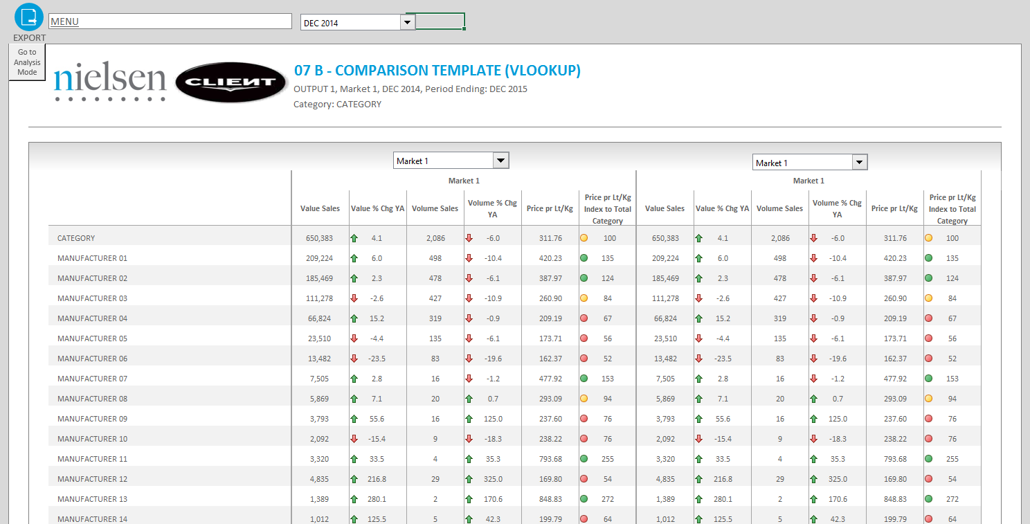

Standard View
Guidelines
Template Name | 07_Discover_Comparison Template - 1 Dimension (Vlookup)
View Name | Standard View
Methodology | VLOOKUP
Default Dimension Order | Page Bar
Default Dimension Order | Columns | 1 Dimensions | Facts
Default Dimension Order | Rows | 1 Dimension | Markets, Periods and Products
Change dimension | - The dimensions can be swapped  - If a different layout is needed (for example, 2 dimensions on the columns) please select a different template  - Dimension can be swapped by changing the data set in the add-in following this order:  - Dimension in Drop Down 1 and Drop Down 2: First Position in Data set Rows  - Dimension in Drop Down 3: Second Position in Data set Rows  - Dimension in Row Table: Third Position in Data set Rows  - Dimension in Template Columns: in Data set Column
Data Selection Guidelines | Facts | - No limitation in number
Data Selection Guidelines | Products | - No limitation in number  - Product selections start always with the Total Category followed by other selected items
Data Selection Guidelines | Markets | - No limitation in number
Data Selection Guidelines | Periods | - No limitation in number
Data Selection Guidelines | NOTE: For the dimension in the Page Bar, the maximum number of items is 100  IMPORTANT:  - If report performance is poor, i.e., file opening and changing drop down selections take longer than several seconds (not acceptable by end user), remove any unused data rows from each Output Sheet, to improve user experience.  *Poor performance can be observed mostly in reports with multiple Output Sheets.  Example Scenario:  *Before removing rows, ensure you do not remove any important part of report configuration area.  RATIONALE: Individual cells in each row contain formulas, which need to be re-calculated every time a report is opened or drop down selection is changed. These additional operations, which run in the background, can negatively impact report performance, e.g., in a template with 40 formulas per row and 390 unused rows, the number of unnecessary operations is ~15600.
  Description | # Rows
  Default number of data rows handled by template | 500
  Number of items in rows (current report selection) | 60
  Buffer for any fluctuations in rows (deletions/additions of items in the future) | 50
  Unused number of data rows to be removed | 500-(60+50) = 390
To create a new report from this template | - Welcome Sheet – Insert all the needed information on the Configuration Area  - Output Sheet – Insert all the needed information on the first Row in the Parallel of the Table, if you add more Columns.  - Add or delete the needed columns to accommodate the retrieved information  - Never delete column outside the print Area.  - Depending on the number of periods and facts, the table formatting will have to be adjusted  - To make formatting easier, the existing formats can be copied  - When the new source Sheet using the add-in is created, you have to run the following Macro: InsertColumns()  - Add a Freeze Panes if needed (In case all the columns can’t be shown in the screen or long list of rows).

